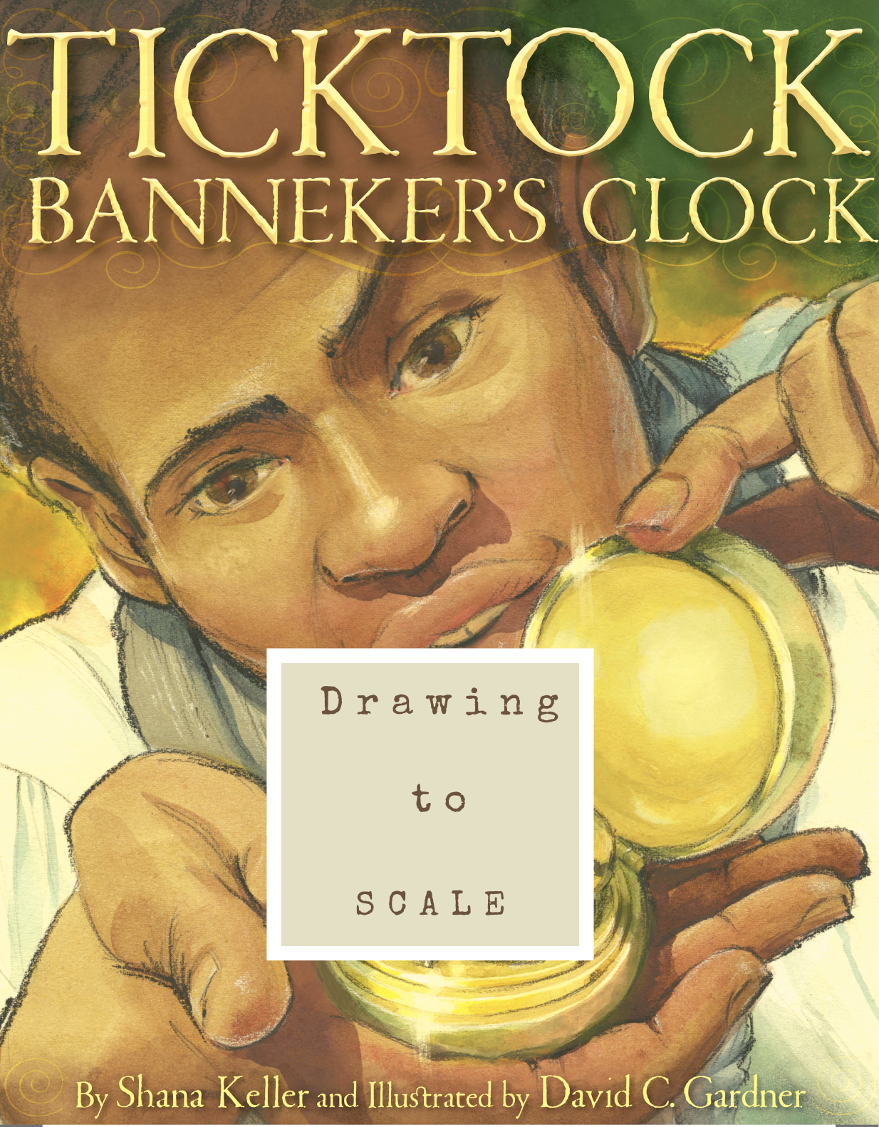
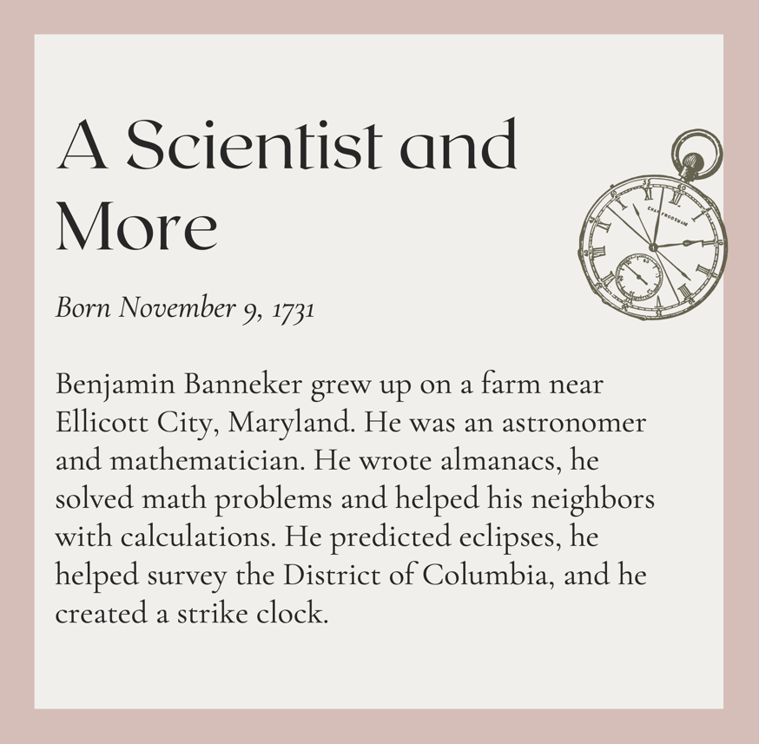

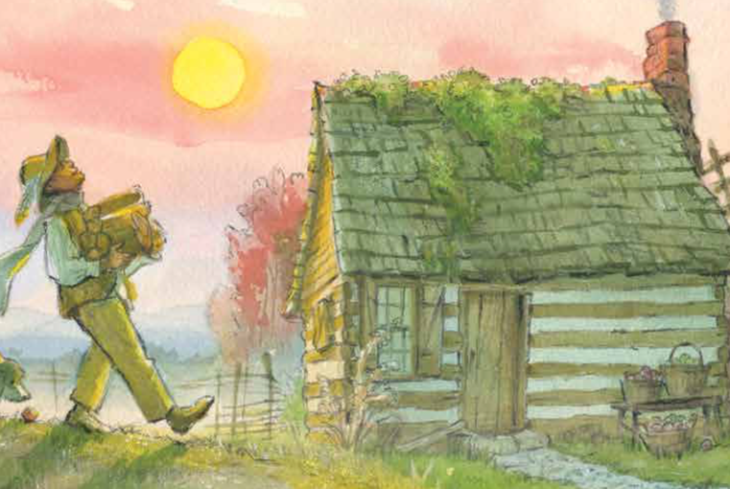
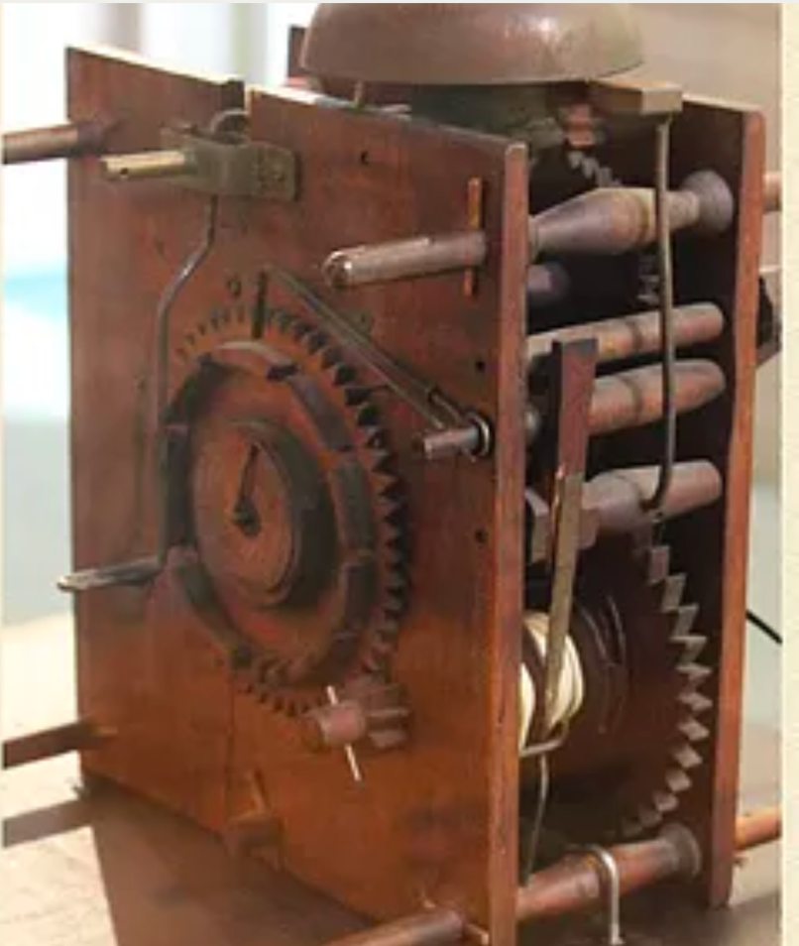
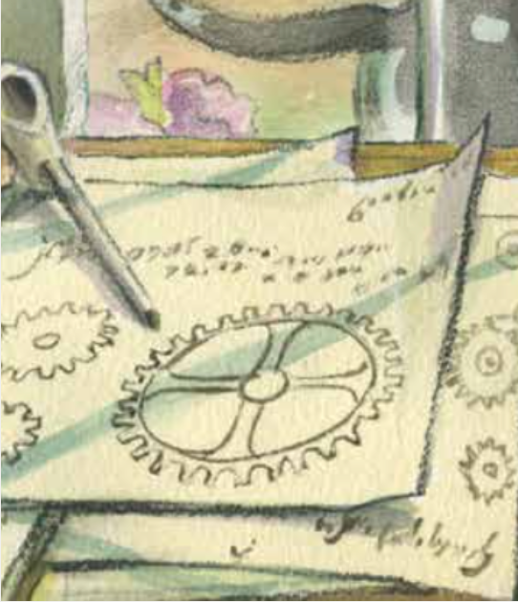

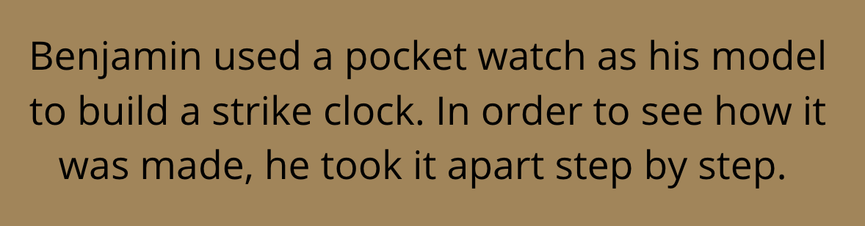

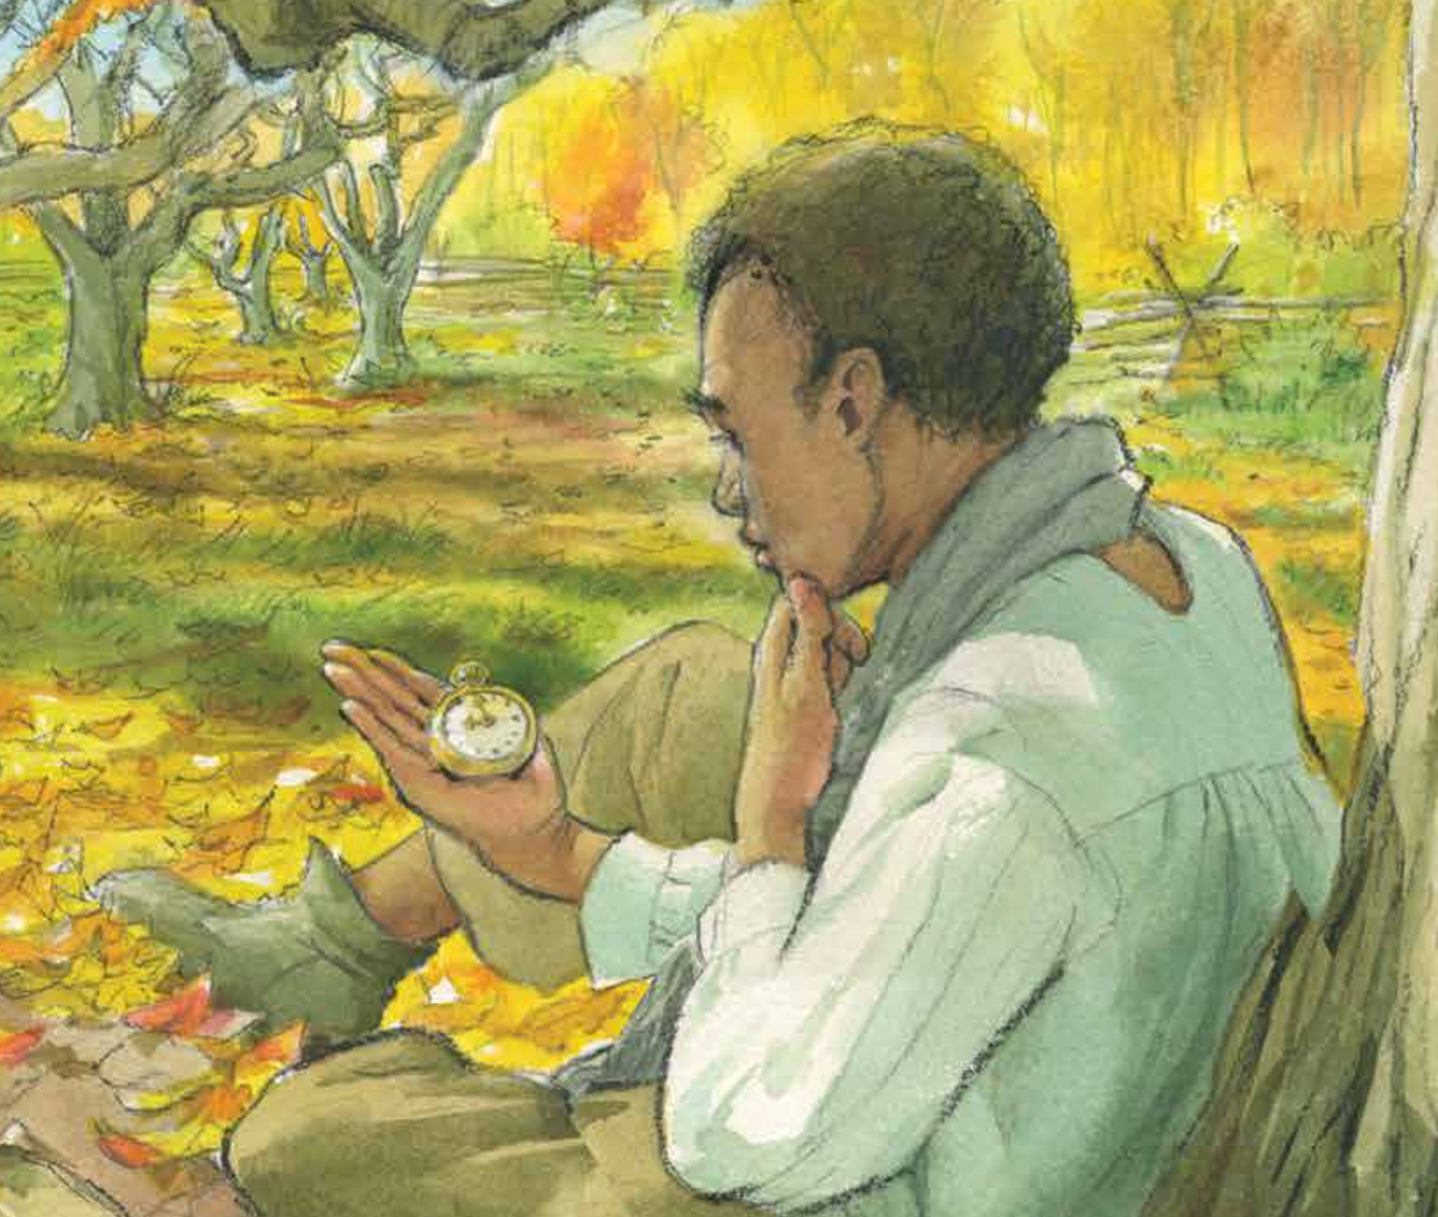
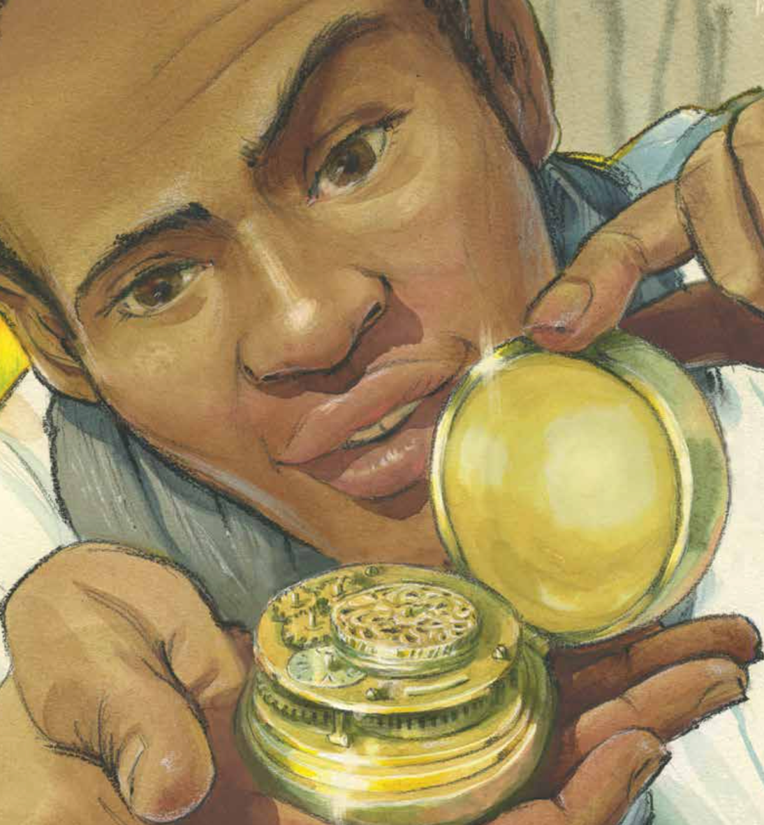

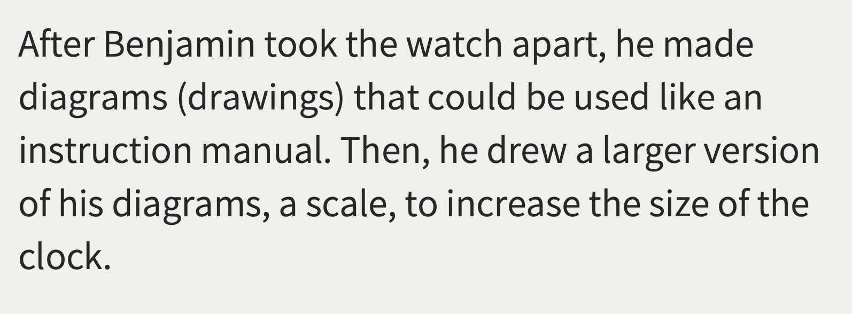

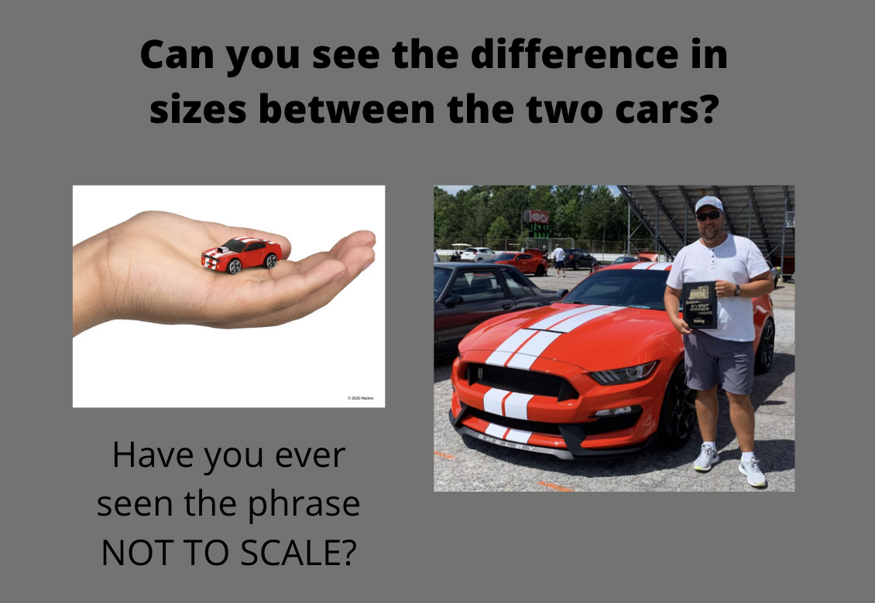
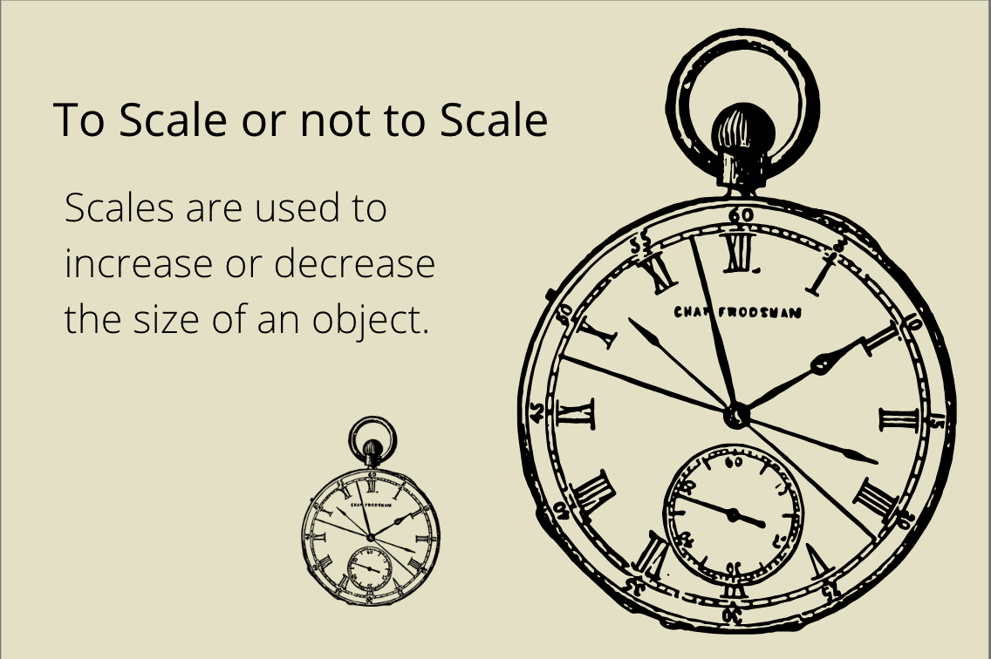

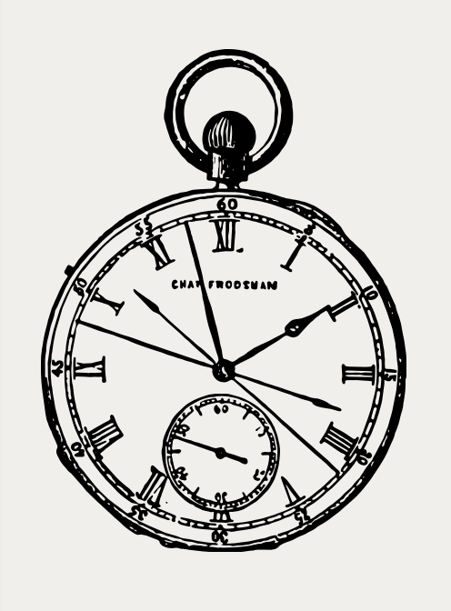

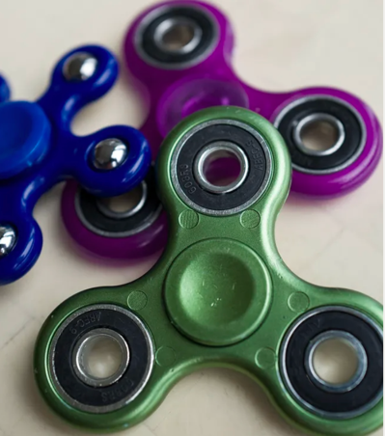
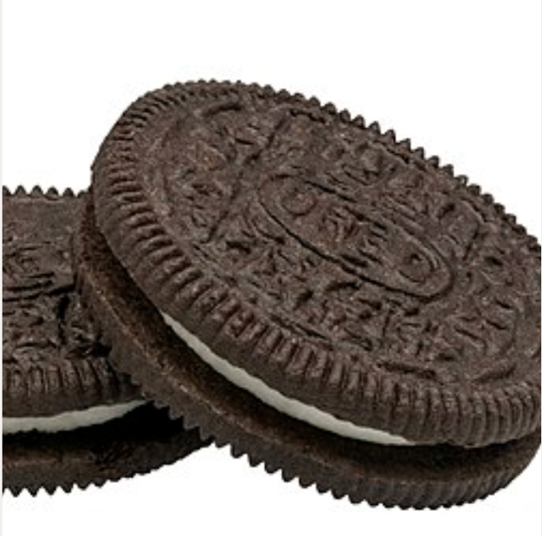

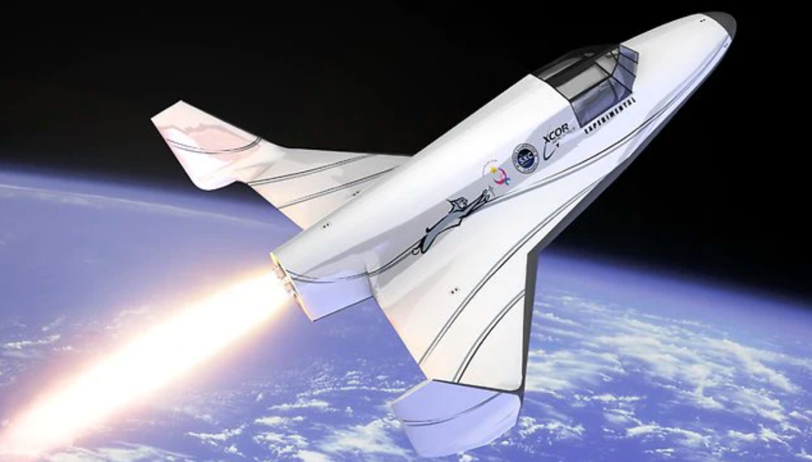

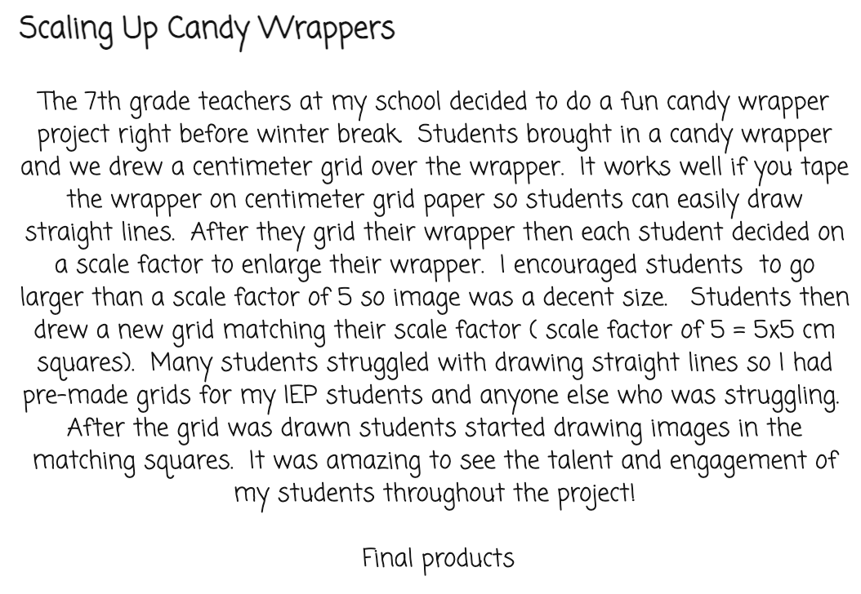
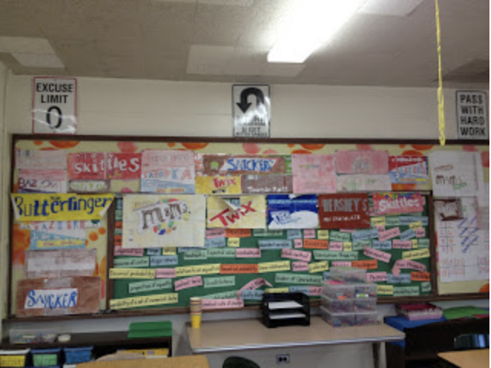
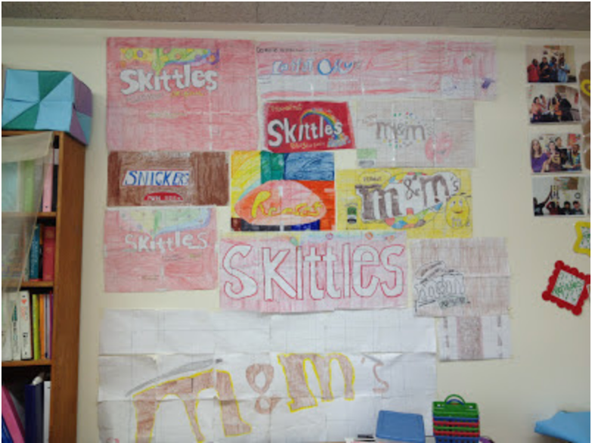

SCALING UP CANDY WRAPPERS:
http://fasttimesofamiddleschoolmathteacher.blogspot.com/2013/01/scaling-up-candy-wrappers.html?spref=tw

MATH IDEA GALAXY:
https://ideagalaxyteacher.com/8-scale-drawing-activities/

KERRY TRACY, FEEL-GOOD TEACHING:
https://www.teacherspayteachers.com/Product/Ticktock-Bannekers-Clock-Distance-Learning-5825087

TEACHABLE RESOURCEFUL LEARNERS:
https://www.teacherspayteachers.com/Product/Tick-Tock-Bannekers-Clock-Book-Activities-4680821

ADDITIONAL RESOURCES ARE ON MY WEBSITE:
www.shanakeller.com

